SRINIVAS UNIVERSITY
INSTITUTE OF EDUCATION

RANK LIST OF B.Ed. 2018-19 BATCH

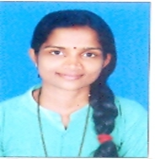  Ms Saritha Kumari N  1st Rank and Gold Medal  B.Ed. | Mr. Suresh B  2nd Rank  B.Ed. | Ms. Sowmya Naik  3rd Rank  B.Ed.
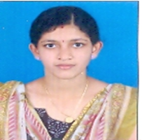  Ms. Vidyashree P  4th Rank  B.Ed. | 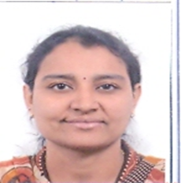  Ms. Chinmayi G  5th Rank  B.Ed. | Ms. Sumitha K  6th Rank  B.Ed.

**********************

